1. **Problem definition and description**

The main purpose of the project is to apply fast Fourier transform on the vibration signal data to figure out the natural frequency of a building by floor, and to discuss its effectiveness of the technique in terms of dimensionality reduction.

Fourier transform is a mathematical function which transforms a signal from the time domain to the frequency domain. The reason why this is a very powerful transformation is that it allows us to understand the complex signal into some combinations of frequencies. Then, fast Fourier transform is an algorithm to perform a quick Fourier transform of discrete, real world data.

1. **Core code**

# imported libraries

import pandas as pd

import numpy as np

import matplotlib.pyplot as plt

# read data

df = pd.read_csv("5StorySteelStructure.csv", header=None)

# perform fast Fourier transform

df1 = np.fft.fft(df[1])

df1_len = np.fft.fftfreq(df1.size, 1/180)

df2 = np.fft.fft(df[2])

df2_len = np.fft.fftfreq(df2.size, 1/180)

df3 = np.fft.fft(df[3])

df3_len = np.fft.fftfreq(df3.size, 1/180)

df4 = np.fft.fft(df[4])

df4_len = np.fft.fftfreq(df4.size, 1/180)

df5 = np.fft.fft(df[5])

df5_len = np.fft.fftfreq(df5.size, 1/180)

# plot the data

fig = plt.figure(figsize = [18, 18]) # fig

ax_1 = fig.add_subplot(521) # first floor

ft_1 = fig.add_subplot(522) # first floor fft

ax_2 = fig.add_subplot(523) # second floor

ft_2 = fig.add_subplot(524) # second floor fft

ax_3 = fig.add_subplot(525) # third floor

ft_3 = fig.add_subplot(526) # thrid floor fft

ax_4 = fig.add_subplot(527) # fourth floor

ft_4 = fig.add_subplot(528) # fourth floor fft

ax_5 = fig.add_subplot(529) # fifth floor

ft_5 = fig.add_subplot(5, 2, 10) # fifth floor fft

ax_1.plot(df[0], df[1], color='red')

ft_1.plot(abs(df1_len), abs(df1), color='red')

ax_2.plot(df[0], df[2], color='orange')

ft_2.plot(abs(df2_len), abs(df2), color='orange')

ax_3.plot(df[0], df[3], color='green')

ft_3.plot(abs(df3_len), abs(df3), color='green')

ax_4.plot(df[0], df[4], color='purple')

ft_4.plot(abs(df4_len), abs(df4), color='purple')

ax_5.plot(df[0], df[5], color='blue')

ft_5.plot(abs(df5_len), abs(df5), color='blue')

ax_5.set_xlabel('time')

ax_3.set_ylabel('vibration')

ft_5.set_xlabel('frequency')

ft_3.set_ylabel('vibration')

1. **Results and plots**

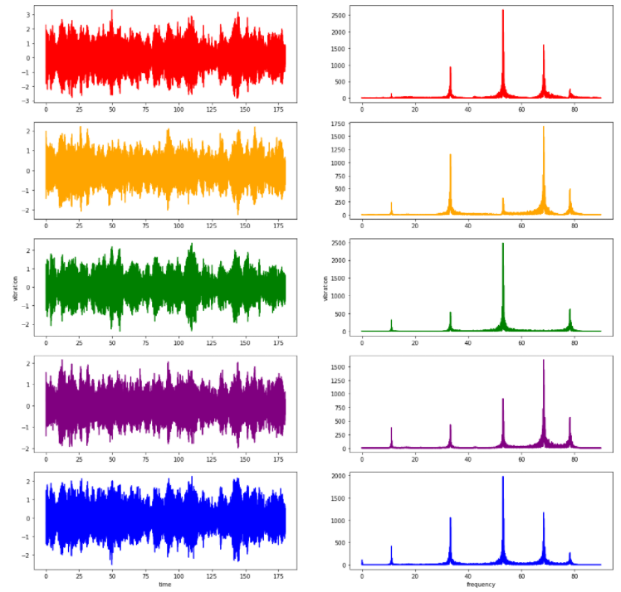

**Figure 1. Plotting of the original data (left) and the result of fast Fourier transform (right)**

1. **Discussion**

**Floor vibrations**: There are sources of vibrations in buildings: human activities, vibrating machinery, or external forces such as traffic, wind or earthquakes. Due to the impacts of those sources, the safety guidelines of those buildings have been considered.

**Results of the transform**: According to Figure 1, the main frequencies of each floor have been analyzed. Since the units of the data has not been provided, we could not know the exact frequency with accurate unit, but we can mainly see the most intense frequencies on the graphs. (Outlined in green) It seems that the frequency components of the vibrations are identical among floors, but the intensity or power are different.

**Results and building safety**: The buildings’ natural frequency depends on its self-weight, stiffness and height. Since there are numbers of studies said that low frequencies cause the biggest problems fifth floor seems to have the most unstable structure.

**Results and Dimensionality reduction**: Since we cannot clearly know the main components of discrete observations of real world in a glance, Fourier transforms are needed to figure out the main sinuous components. Dimensionality reduction is definitely performed if we count each sinuous wave as a dimension of the original wave.

1. **Refernces**

Tony DiCola. FFT: Fun with Fourier Transforms. <https://learn.adafruit.com/fft-fun-with-fourier-transforms/background>